**DBMS LAB 3**

**Railway Reservation**

By: Ishita Bharadwaj

SRN: PES1UG20CS648

Section: K

Roll No: 43

Create tables for the Above-mentioned Relational design and add check, default, not null and unique constraints.

1) Added PK and FK constraints for all applicable Relations

**CREATE DATABASE PES1UG20CS648_railway**

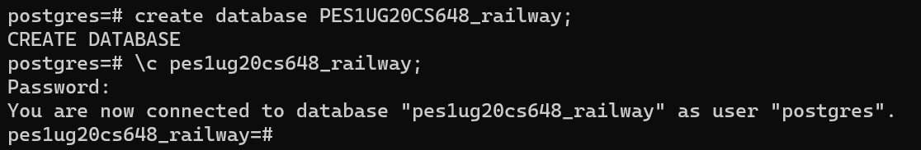

2) For Train_name, Train_Type in Train table add not null constraints value

**Create Table Train**

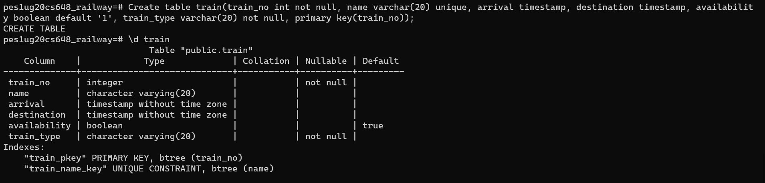

Train name is unique (which is not null). Train type and train number is not null.

3) Add default constraint for compartment table setting Availability attribute to Yes –

Availability constraint is default to ‘yes’ as the data type for availability is Boolean – 1 for yes and 0 for no.

**Create Table Compartment**

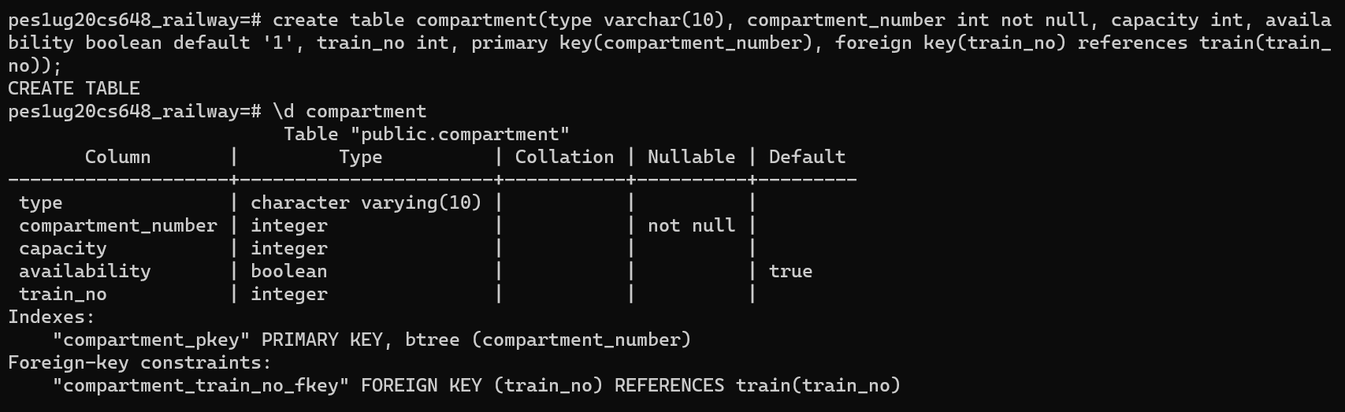

**create table route_info**

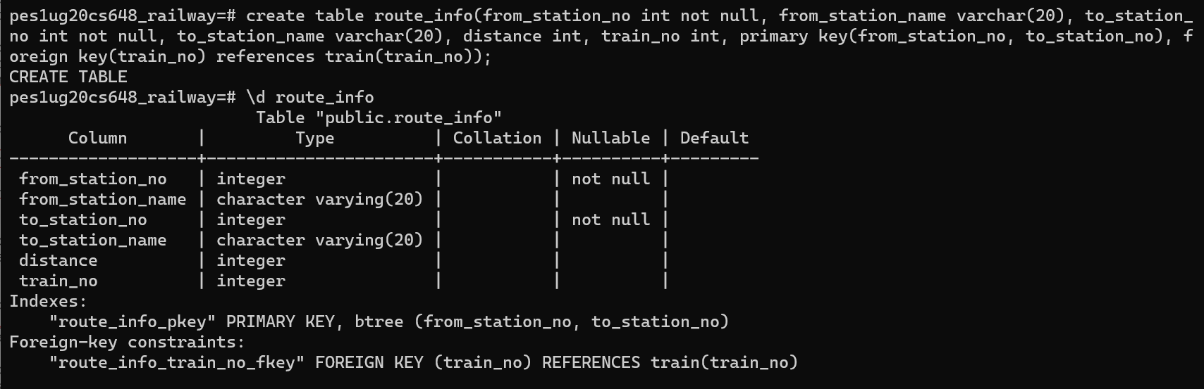

**create table user_t**

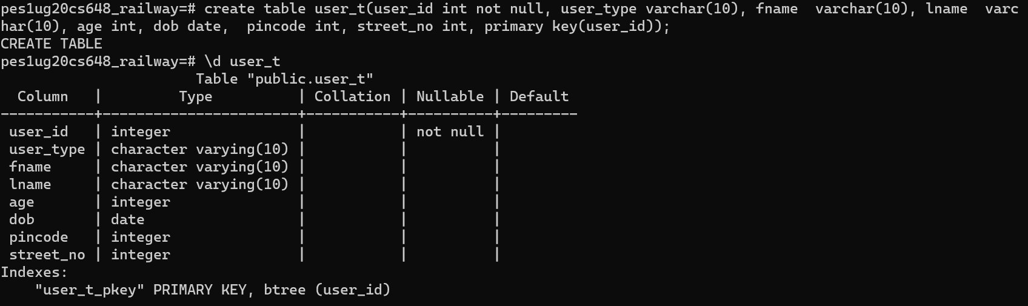

**create table user_train**

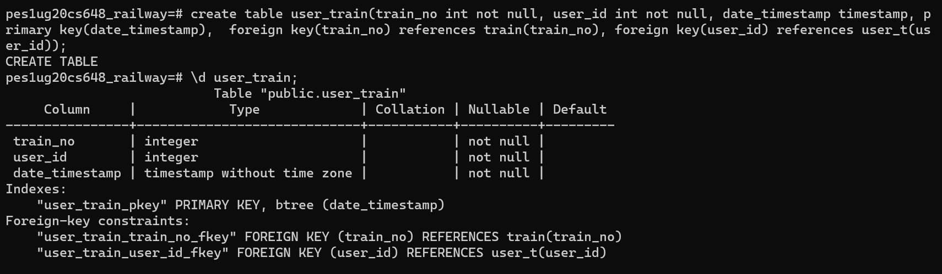

**Create table user_phone**

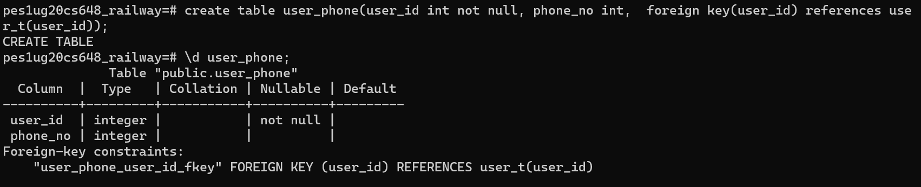

**Create table ticket**

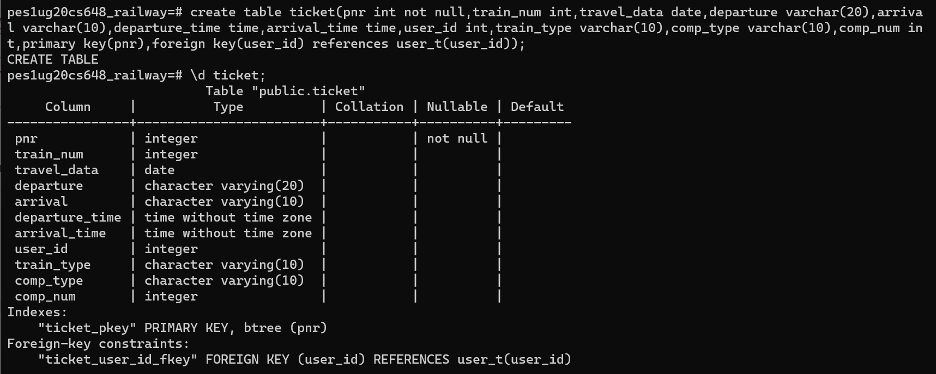

**Create table payment_info**

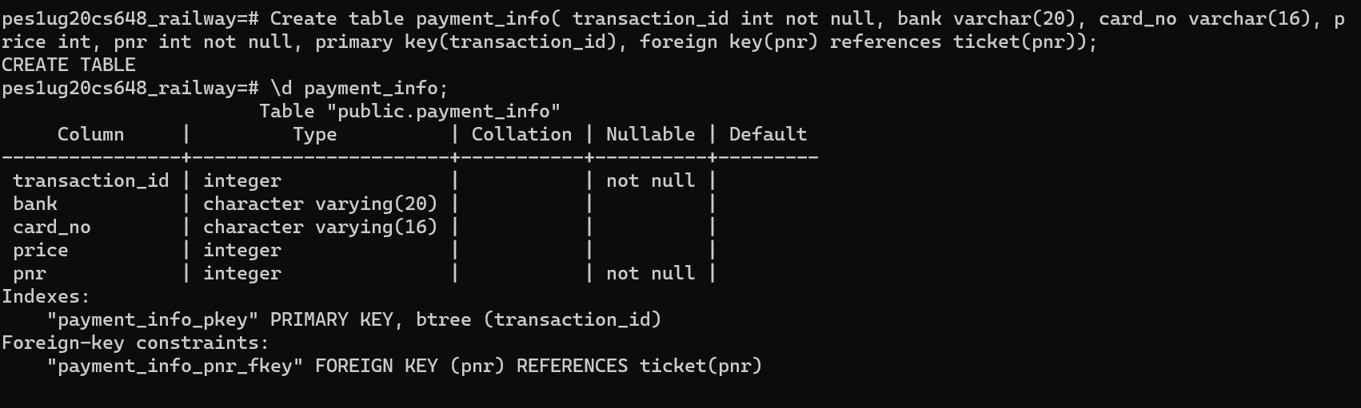

**Create table ticket_passenger**

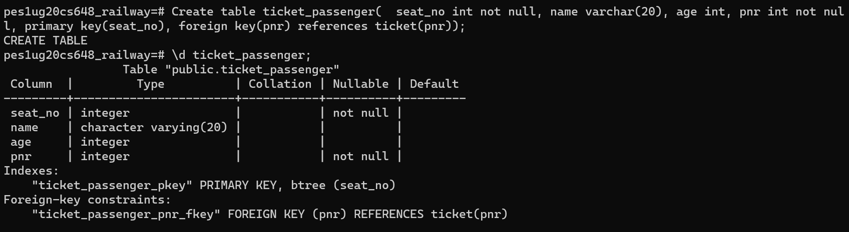

**Create table fare**

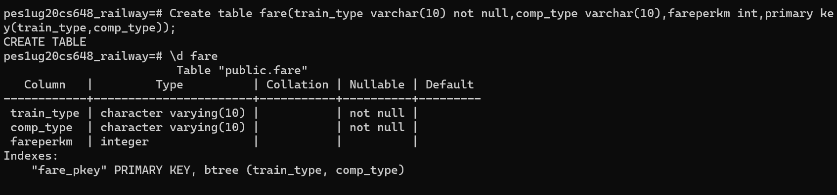

4)train name should be unique-

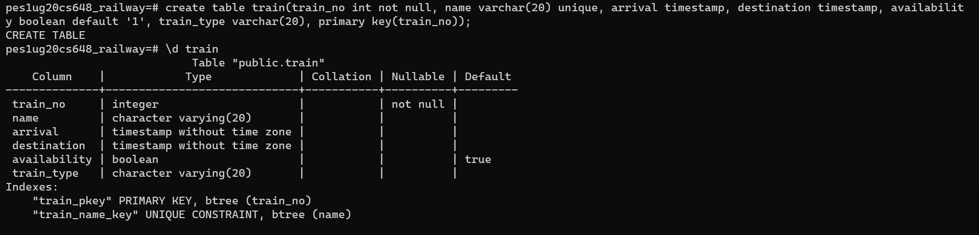

5) Add check constraints to Ticket to check if the passenger age is above 5

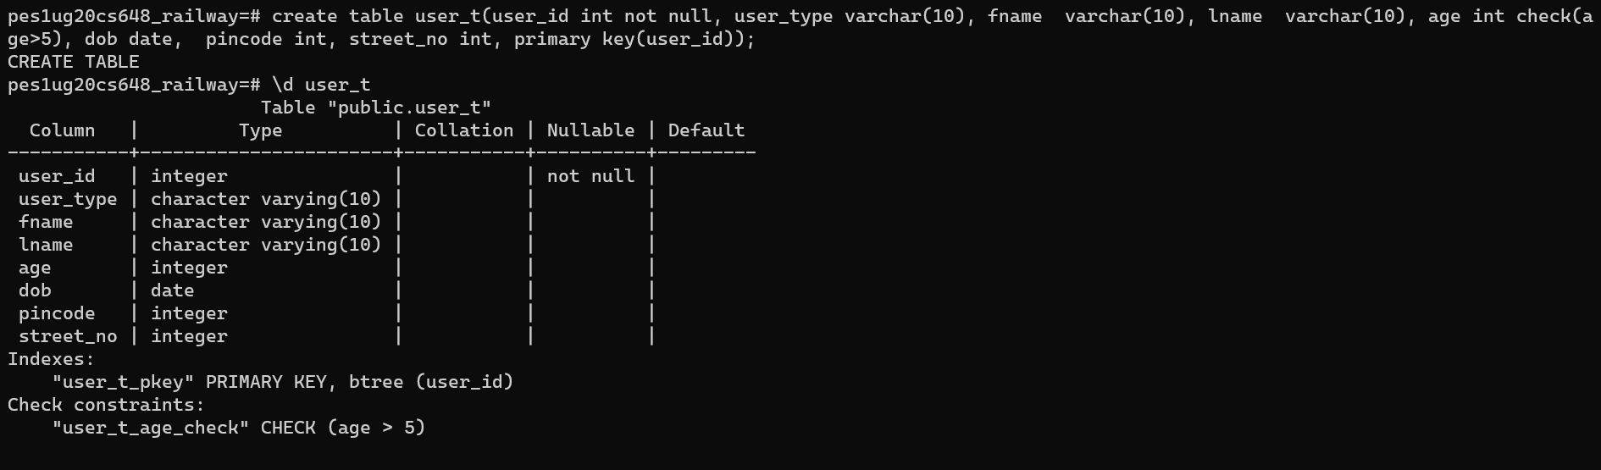

6) Rename any existing table name : alter table user_t

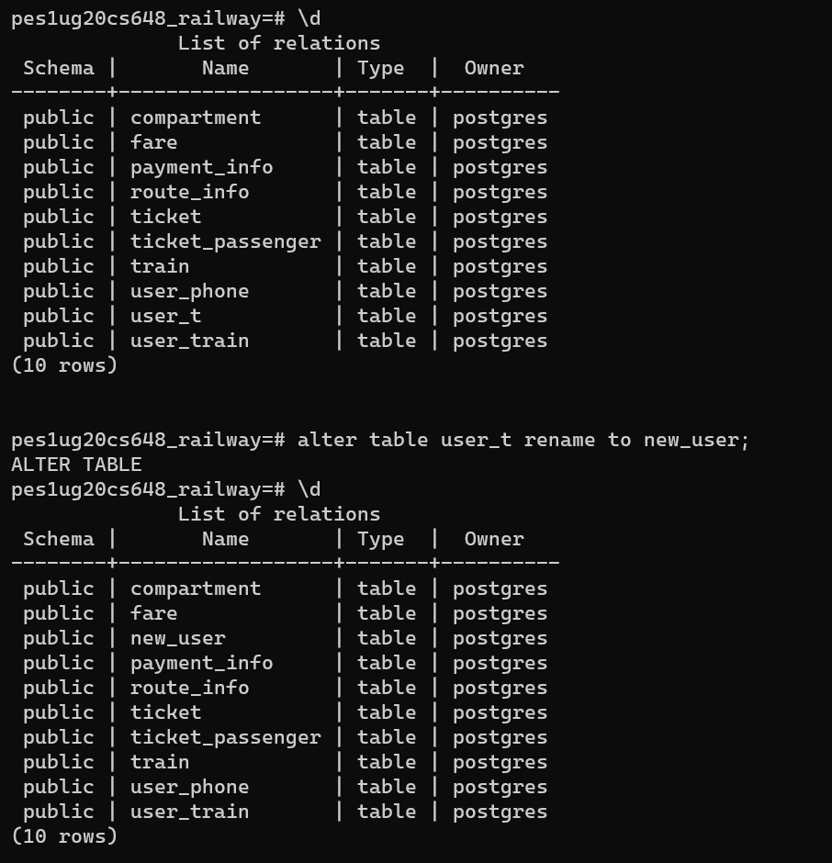

7) use Truncate and drop commands

